# **Information**

**All placeholders are always working for one application and one snapshot**

**You can copy/paste each placeholder below by selecting the full content.**

**Some of placeholders could have parameters to modify**

**Sample, you can choose the number of lines you want to display and you can decide for which Business Criteria, you want to link your placeholder**

## **Text placeholders**

Select the text box, right click for the contextual menu, then Format Shape.

In the Format Shape menu, Shape Options, Layout & Properties, Alt Text, fill the Description field with the component options

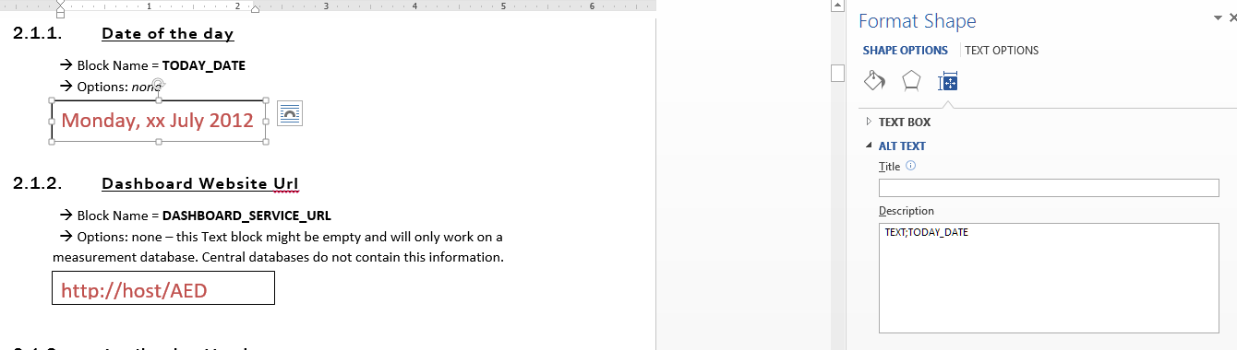

## **Graph placeholders**

Select the chart, right click for the contextual menu, then Format Chart Area.

In the Format Chart Area menu, Chart Options, Layout & Properties, Alt Text, fill the Description field with the component options

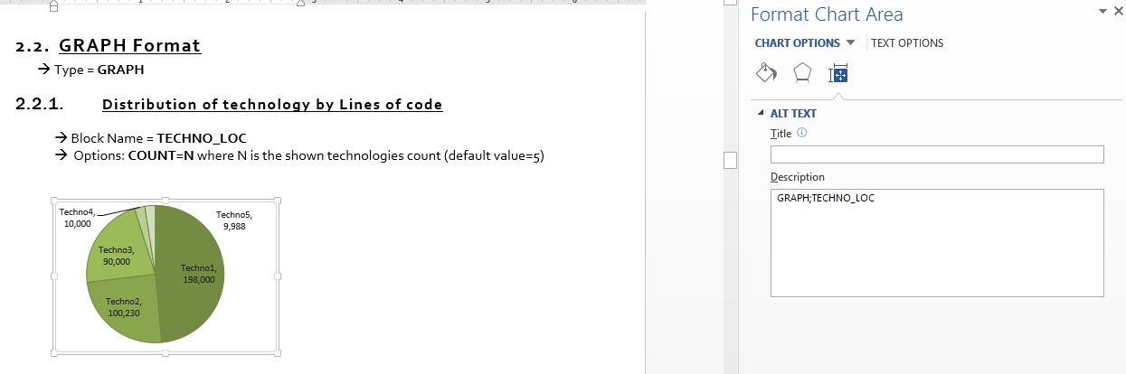

## **Table placeholders**

Select the table, right click for the contextual menu, then Table Properties.

Alt Text tab, fill the Description field.

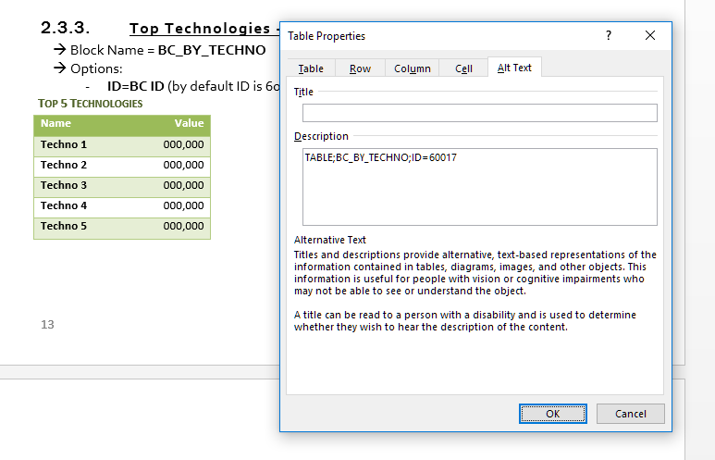

# **List of available Place Holders**

## **TEXT Format Blocks**

🡪 Type = **TEXT**

### **Category selected**

🡪 Block Name = **PF_CATEGORY_NAME**  
 🡪 Options: If no category selected, « all » value is displayed

CategoryName

### **Tag selected**

🡪 Block Name = **PF_TAG_NAME**  
 🡪 Options: If no category selected, « all » value is displayed

TagName

### **Number of Applications**

🡪 Block Name = **PF_#APPLICATIONS**  
 🡪 Options: *none*

numberOfApps

### **Technical Debt ratio per AFP – deprecated (old Cast formula)**

🡪 Block Name = **PF_TECHDEBT_VS_AFP**  
🡪 Options: *none*

value

### **Technical Debt ratio per LOC deprecated (old Cast formula)**

🡪 Block Name = **PF_TECHDEBT_VS_LOC**  
🡪 Options: *none*

value

### **Number of Critical Violations**

🡪 Block Name = **PF_CRITICAL_VIOLATIONS**  
🡪 Options: **BCID=N** where N is an health factor (by default 60017)

value

### **OMG Technical Debt ratio per AFP**

Display the total of OMG technical debt per AFP in Days

🡪 Block Name = **PF_OMG_TECHDEBT_VS_AFP**  
🡪 Options: *ID = ISO or AIP or CISQ (by default if not exists : ISO)*

value

Notes:

* ISO option is the recommended technical debt to be used. Requires installation of OMG Technical Debt Measure (>2.0.0 funcrel) and ISO-5055 Index extensions during analysis
* CISQ option required installation of OMG Technical Debt Measure and CISQ Index extensions during analysis. Scope of rules is reduced

### **OMG Technical Debt ratio per KLOC**

Display the total of OMG Technical Debt per KLOC in Days

🡪 Block Name = **PF_OMG_TECHDEBT_VS_KLOC**  
🡪 Options: *ID = ISO or AIP or CISQ (by default if not exists : ISO)*

value

Notes:

* ISO option is the recommended technical debt to be used. Requires installation of OMG Technical Debt Measure (>2.0.0 funcrel) and ISO-5055 Index extensions during analysis
* CISQ option required installation of OMG Technical Debt Measure and CISQ Index extensions during analysis. Scope of rules is reduced

### **Custom Expression**

🡪 Block Name = **PF_CUSTOM_EXPRESSION**   
 🡪 Options =

* PARAMS=SZ a SZ b, (SZ pour sizing measure, QR pour quality rule, BF for background fact)
* EXPR=b/a, (operators can be +, -, *, / , (, ) )
* a=67011,
* b=67010,
* FORMAT=N0 (N2 by default, if nothing or erroneous format is set),
* AGGREGATOR=SUM|AVERAGE (for portfolio component, to aggregate results of all applications for the custom expression, AVERAGE by default or if erroneous format is set)

0.00

You can have as number of parameters as you want (theorical limit is 16383…).

The format of return value is explained here : <https://msdn.microsoft.com/en-us/library/dwhawy9k.aspx>, with examples for double here : <https://msdn.microsoft.com/en-us/library/kfsatb94.aspx> ), only N format is interesting here :

N: -195,489,100.84

N0: -195,489,101

N1: -195,489,100.8

N2: -195,489,100.84

/!\ don’t put blank char in the definition of parameters (,a=67011,b=67010,c=…)

## **GRAPH Format**

🡪 Type = **GRAPH**

### **Technical Debt Trending Progression - deprecated (old Cast formula)**

🡪 Block Name = **PF_TREND_TECH_DEBT** 🡪 Options: *none*

🡪 Note: X axis is based on the last 6 previous quarter starting from today

### **OMG Technical Debt Trending Progression**

🡪 Block Name = **PF_TREND_OMG_TECH_DEBT** 🡪 Options: *ID = ISO or AIP or CISQ (by default if not exists : ISO)*

🡪 Note: X axis is based on the last 6 previous quarter starting from today

Notes:

* ISO option is the recommended technical debt to be used. Requires installation of OMG Technical Debt Measure (>2.0.0 funcrel) and ISO-5055 Index extensions during analysis
* CISQ option required installation of OMG Technical Debt Measure and CISQ Index extensions during analysis. Scope of rules is reduced

### **Critical Violations Delta Trending Progression**

🡪 Block Name = **PF_TREND_CRIT_VIOL** 🡪 Options: **BCID=N** (where N is an health factor (by default 60017)

🡪 Note: X axis is based on the last 6 previous quarter starting from today

### **TQI by Critical Violations/LoC by AFP**

🡪 Block Name = **PF_QS_BY_CVLOC**   
(Only working with PowerPoint 2013, after report generated, need to edit data in excel to get label of applications updated into the graph)  
🡪 Options: *none*🡪 Note: Bubble = application, Size of bubble = AFP

### **List of applications regarding a specific indicator**

🡪 Block Name = **PF_BAR_CHART** 🡪 Options: *METRIC=ID (where ID can be the one of a BC, TC, QR, sizing measure or background fact)*

## **TABLE Format**

🡪 Type = **TABLE**

### **Top Riskiest Application regarding Health Factor**

🡪 Block Name = **PF_TOP_RISKIEST_APPS** 🡪 Options:

* **COUNT=N** where N is the shown technologies count (default value=5)
* **ALT=N (where N is an health factor id - eg. 60017)**

|  |  |  |  |
| --- | --- | --- | --- |
| Application Name | Critical Violations | TQI | Last Analysis Date |
| App 1 | 0 | 0.00 | 1 jan 2010 |
| App 2 | 0 | 0.00 | 1 jan 2010 |
| App 3 | 0 | 0.00 | 1 jan 2010 |
| App 4 | 0 | 0.00 | 1 jan 2010 |
| App 5 | 0 | 0.00 | 1 jan 2010 |

### **SLA view**

🡪 Block Name = **PF_BC_RELEASE_PERFORMANCE** 🡪 Options:

* BF=T1 T2 T3 T4 T5 T6 T7 T8 where Tx is a target to fix regarding each line
* SLA=X Y where X is corresponding to the a% and Y is corresponding to the b% in the formula below

**SLA Assessment thresholds :**

* Good if % difference between Target and Actual is less than a%
* Acceptable if & difference between Target and Actual is between a% and b%
* Poor if % difference between Target and Actual is greater than b%

**Actual score :** average score using latest snapshot data (even if snapshot date is before current quarter

**Target score:** score to reach, to be configured as an option of the component

**Score from previous quarter:** average score using snapshot from previous quarter. If last snapshot date is old and previous current quarter, last snapshot date will be used also for previous quarter calculation

|  |  |  |  |  |
| --- | --- | --- | --- | --- |
| Application Quality Measure | Previous Quarter | Target Score | Actual Score | SLA Assesment |
| Robustness | 0.00 | 0.00 | 0.00 | Good |
| Security | 0.00 | 0.00 | 0.00 | Good |
| Efficiency | 0.00 | 0.00 | 0.00 | Good |
| Changeability | 0.00 | 0.00 | 0.00 | Good |
| Transferrability | 0.00 | 0.00 | 0.00 | Good |
| Programming Practices | 0.00 | 0.00 | 0.00 | Good |
| Documentation | 0.00 | 0.00 | 0.00 | Good |
| Architectural Design | 0.00 | 0.00 | 0.00 | Good |

### **Generic SLA view**

🡪 Block Name = **PF_TABLE_RELEASE_PERFORMANCE** 🡪 Options:

* ID=ID1|ID2|ID3… where Idx is the metric id of the quality indicator (BC, TC or QR) to assess
* TARGETS=T1|T2|T3… where Tx is a target to fix regarding each line, if only one target, it will be used for all metrics
* SLA=X|Y where X is corresponding to the 2% and Y is corresponding to the 5% in the formula below

**SLA Assessment thresholds :**

* Good if % difference between Target and Actual is less than 2%
* Acceptable if & difference between Target and Actual is between 2% and 5%
* Poor if % difference between Target and Actual is greater than 5%

**Actual score :** average score using latest snapshot data (even if snapshot date is before current quarter

**Target score:** score to reach, to be configured as an option of the component

**Score from previous quarter:** average score using snapshot from previous quarter. If last snapshot date is old and previous current quarter, last snapshot date will be used also for previous quarter calculation

|  |  |  |  |  |
| --- | --- | --- | --- | --- |
| Application Quality Measure | Previous Quarter | Target Score | Actual Score | SLA Assesment |
| Total Quality Index | 0.00 | 0.00 | 0.00 | Good |
| Efficiency - Expensive Calls in Loops | 0.00 | 0.00 | 0.00 | Good |
| Avoid large Classes - too many Methods (JEE) (4554) | 0.00 | 0.00 | 0.00 | Good |
| Avoid Classes with a very low comment/code ratio (7780) | 0.00 | 0.00 | 0.00 | Good |

### **Identification of Ignored Applications or Snapshots**

The following block provides potential applications or snapshots of application that didn’t work during calculation of other blocks. Investigation into the central for the application or snapshot listed must be done.

🡪 Block Name = **PF_IGNORED_APPLICATIONS**🡪 Options: none

|  |
| --- |
| Ignored Apps |
| App 1 |
| App 2 |
| App 3 |
| App 4 |
| App 5 |

🡪 Block Name = **PF_IGNORED_SNAPSHOTS**🡪 Options: none

|  |
| --- |
| Ignored Snapshots |
| Snap 1 href |
| Snap 2 herf |
| Snap 3 herf |
| Snap 4 herf |
| Snap 5 herf |

### **Mapping Name/ Id indicator**

The following block provides numbers to use for ID values.

🡪 Block Name = **ID_NAME_INDICATOR_MAPPING**🡪 Options: none

|  |  |
| --- | --- |
| Name | Id |
| Total Quality Index | 60017 |
| Security | 60016 |
| Robustness | 60013 |
| Performance | 60014 |
| Changeability | 60012 |
| Transferability | 60011 |
| ProgrammingPractices | 66031 |
| ArchitecturalDesign | 66032 |
| Documentation | 66033 |
| SEIMaintainability | 60015 |
| CostComplexityDistribution | 67001 |
| CyclomaticComplexityDistribution | 65501 |
| OOComplexityDistribution | 65701 |
| SQLComplexityDistribution | 65801 |
| CouplingDistribution | 65350 |
| ClassFanOutDistribution | 66020 |
| ClassFanInDistribution | 66021 |
| SizeDistribution | 65105 |